**PROJECT REPORT**

**Owl-M : A Material Design Study App**

**1.INTRODUCTION**

* 1. **OVERVIEW**

Owl-M is a Material Design Study App project that aims to provide a seamless and intuitive user experience for students and learners of all ages. The app is designed to help users study efficiently and effectively by providing them with a range of features and tools that facilitate learning.

One of the key features of Owl-M is its material design interface, which is based on Google's Material Design principles. This interface is designed to be simple, intuitive, and easy to use, which makes it ideal for students who are often busy and need to be able to quickly access their study materials.

In addition to its interface, Owl-M also includes a range of study tools, such as flashcards, quizzes, and note-taking functionality. These tools are designed to help users reinforce their learning and improve their retention of key concepts.

Another important aspect of Owl-M is its ability to customize learning experiences to each user's specific needs. The app can track users' progress and adapt its recommendations and study materials accordingly, ensuring that each user is receiving the most relevant and helpful content for their learning goals.

Overall, Owl-M is a comprehensive and user-friendly study app that is designed to help students of all ages and levels succeed in their academic pursuits.

**1.2 PURPOSE**

The purpose of Owl-M, a Material Design Study App project, is to provide a comprehensive and user-friendly app that helps students study efficiently and effectively. The app is designed to make learning easier by providing a range of features and tools that reinforce learning and improve retention of key concepts.

One of the main goals of Owl-M is to provide a seamless and intuitive user experience for learners of all ages. This is achieved through the use of a material design interface that is based on Google's Material Design principles. The interface is simple, intuitive, and easy to use, which makes it ideal for students who are often busy and need to be able to quickly access their study materials.

Another goal of Owl-M is to provide a range of study tools that can be customized to each user's specific needs. These tools include flashcards, quizzes, and note-taking functionality, which help users reinforce their learning and improve their retention of key concepts. Additionally, the app can track users' progress and adapt its recommendations and study materials accordingly, ensuring that each user is receiving the most relevant and helpful content for their learning goals.

Overall, the purpose of Owl-M is to make learning more accessible and efficient by providing students with a range of tools and resources that are tailored to their individual needs. By using this app, students can improve their academic performance and achieve their learning goals more effectively.

**2.Problem Definition & Design Thinking**

**2.1 Empathy Map**

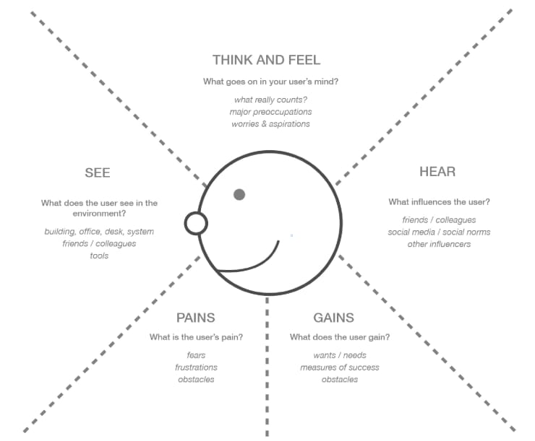

**2.2 Ideation & Brainstorming Map**

Sure, here is an ideation and brainstorming map for Owl-M, a Material Design Study App project:

Problem:

Students have difficulty studying efficiently and effectively, and need a tool to help them stay organized and on track.

Solution:

Create an app that helps students study more efficiently and effectively, by providing them with a range of features and tools that reinforce learning and improve retention of key concepts.

Features:

1. Material design interface for intuitive and easy-to-use experience.
2. Flashcards to reinforce learning and memorize key concepts.
3. Quizzes to test knowledge and assess understanding.
4. Note-taking functionality to summarize and organize information.
5. Study schedule feature to help users stay on track with their studying.
6. Progress tracking feature to measure and monitor improvement.
7. Personalized recommendations based on user performance and goals.
8. Integration with popular educational platforms like Google Classroom and Canvas.
9. Social sharing feature to allow users to share notes and study materials with classmates.
10. Gamification elements to make studying more engaging and fun.

Potential Challenges:

1. Ensuring that the app is accessible and user-friendly for learners of all ages and levels.
2. Finding ways to personalize the app to each user's specific needs and goals.
3. Integrating with educational platforms without compromising user privacy or security.
4. Creating engaging gamification elements that are effective in improving learning outcomes.
5. Ensuring that the app remains up-to-date and relevant as new learning technologies emerge.

Next Steps:

1. Conduct user research and gather feedback on potential features and tools.
2. Prototype and test different iterations of the app with real users.
3. Refine and improve the app based on user feedback and testing results.
4. Launch the app and continue to monitor and improve its performance and user experience over time.

**3.RESULT**

**LOGIN SCREEN**

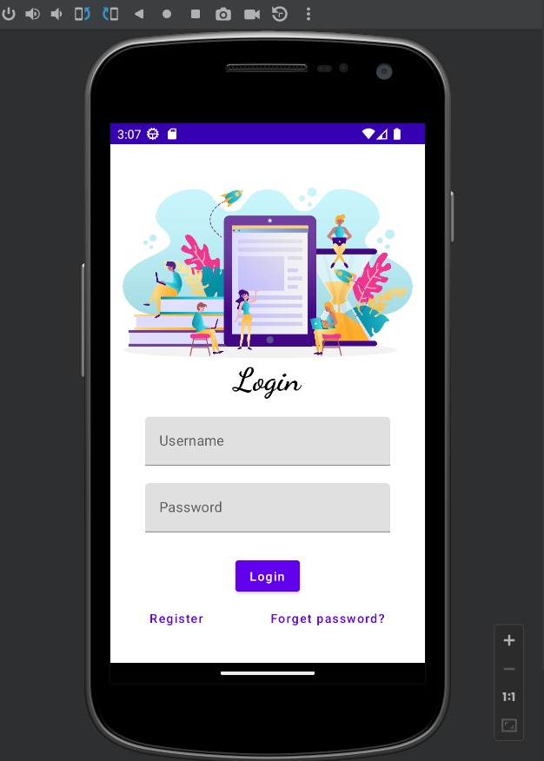

**REGISTER**

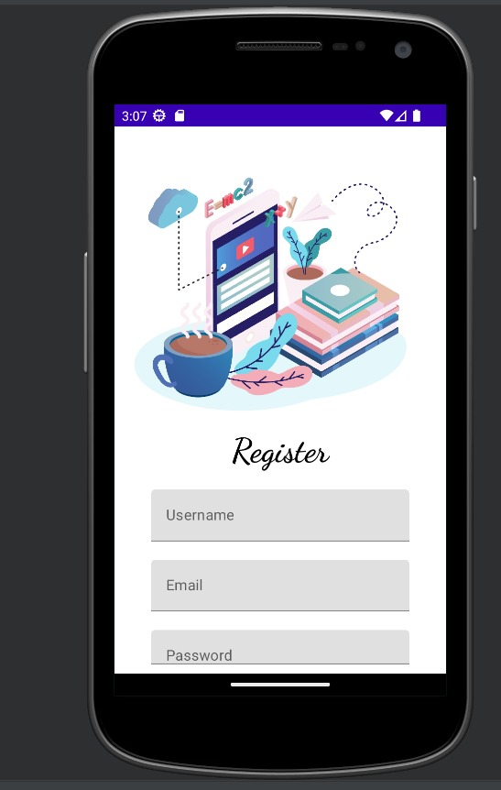

**4.TRAILHEAD PROFILE PUBLIC URL**

Team Lead - TAMILARASI.P -

Team Member 1 - VIJAYASHANTHI.N

Team Member 2 - DHARUN.T

Team Member 3 - SANGAMESWARAN.S

**5.ADVANTAGES & DISADVANTAGES**

**5.1 ADVANTAGES**

1. Graceful animations

Material designs come with smooth, engaging, and flexible UI transitions and animations, making it easier for users to understand the relationship between different elements on their devices. Animations not only clarify the relationship of UI components but also help craft user’s attention at specific points. For example, movement from one screen to another or hovering over/clicking any element on your web page can be used to highlight certain elements such as images or buttons, etc.

2. Responsive layout

It offers fast-scrolling screens and quick content updates, which are important for the mobile age. The use of fast page-switching animations helps users navigate through different screens without having to wait for the screen to load. The ‘card’ layout design makes it easier to scroll vertically or horizontally, whereas elements inside each card can be pushed across the boundaries of their parent cards with ease.

3. Self-contained UI components

Material design introduces self-contained UI components that are much easier to maintain and recognize. This not only speeds up coding but also creates consistency in the user experience. These reusable UI components come loaded with preset API styles that are ready to be plugged into your website or app’s development framework. Therefore, all you need is just a little knowledge about how these API codes work, and you are good to go

4. Adapts well to all screen sizes

You do not need to worry about how your website or app will look on any device. Material Design takes care of the responsiveness part, providing your app with a uniform look, so users can navigate through their screens easily no matter what device they are using. In addition to this, Google has recently introduced material template theming which helps developers get started by choosing from a set of pre-designed UI components and customizing them according to their needs. This method has been designed specifically for better responsive designs and faster coding.

5. Less time required to create animations

By standardizing the way different elements should be animated inside an application or webpage, material design speeds up the process of making animations. The use of common animation time scales for all elements inside the app or webpage makes it easier to create equilibrium between different components, saving a lot of development time in the process.

6. Material design is flexible

Developers can easily customize this new design language by using color, typography, and graphic elements that best suit their needs. This allows developers to choose the right material design that fits perfectly into their existing UI or UX patterns. Material Design can also be integrated with any CSS framework like Bootstrap, Foundation, etc., which means you can use Google’s official material theme along with third-party plugins like jQuery, JavaScript, etc., resulting in better-animated interfaces for your mobile apps or websites.

**5.2 DISADVANTAGES**

The Material Design has very obvious pros, that doesn’t mean there aren’t cons that go along with using it.

First up, Material Design is immediately identifiable and is strongly associated with Google and, specifically, Android. While this isn’t necessarily a bad thing for everyone, it’s potentially a negative for some.

One big reason that it might be a negative is that it limits the effectiveness of other branding while using the Google design system. Yes, designers can incorporate logos, color palettes (within the Material Design guidelines), and other differentiating factors to support the brand identity, but a product following the Material Design specifications will almost always also be associated with Google.

Since motion and animation are promoted within the Material Design guidelines, sites or apps that don’t incorporate it can seem to users as if they’re missing something. People associate the motion characteristics of Material Design with the visual characteristics, which can leave designs without motion lacking.

Sure, one solution is to always incorporate motion in designs that follow the Material Design specs. But extensive animations can be very resource-heavy on mobile devices, resulting in higher data usage and faster battery depletion. It’s a balancing act designers have to consider when working within the Material Design guidelines.

Beginners may find that the Material Design specification is more complicated and harder to implement than other styles like flat design. Because the Material Design system is so comprehensive, there are a lot more things to consider and adhere to than many new designers may be comfortable with.

**6.APPLICATION**

A material Design apps back when there really where not that many. These days, Material Design is everywhere. Most popular apps use it in one form or another and new apps launch with it every day. Thus, we have redone the list to show some of the best example of Material Design that you can find. Material design use. Even if these apps aren’t the best or most useful, they really rock that Material Design well. Here are the best Material Design apps for Android for the record, this list is unlikely to change because google doesn’t really give out as many design awards as they used to.

**7.CONCLUSION**

If an app is being built primarily for the Android platform, then using Material Design is an easy choice. Because of google widespread adoption, any app based on Material Design principle is going to feel like a native app. That said, there are plenty of other use cases outside of the Android platform where Material Design is a solid choice. As the design system matures even further, those situations are bound to increase. Designers should, at the very least, familiarize themselves with the guideline so that they can determine for themselves when its appropriate to use Material Design, and when other system might be better suited.

**8. FUTURE SCOPE**

Material Design is an Android-oriented design language created by Google, supporting onscreen touch experiences via cue-rich features and natural motions that mimic real-world objects. Designers optimize users’ experience with 3D effects, realistic lighting and animation features in immersive, platform-consistent GUIs. These studies explore real-world design and product limitations through the examination of a set of fictional apps, each designed with unique properties and use cases. Each study illustrates how multiple design decisions are made and how different brands express themselves across a variety of product categories, including retail, music, productivity, finance, on-demand services, and education. A dedicated page explains the rationale behind each Material study’s design, the choice of components, and how each study uses Material Theming.

**9.APPENDICES**

**A. SOURCE CODE**